C++

STUDENT GUIDE

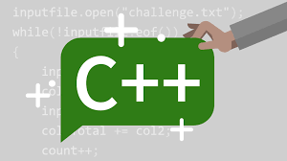

HANDS ON 1: My First Program

1. Get your hand dirty by following the code below!

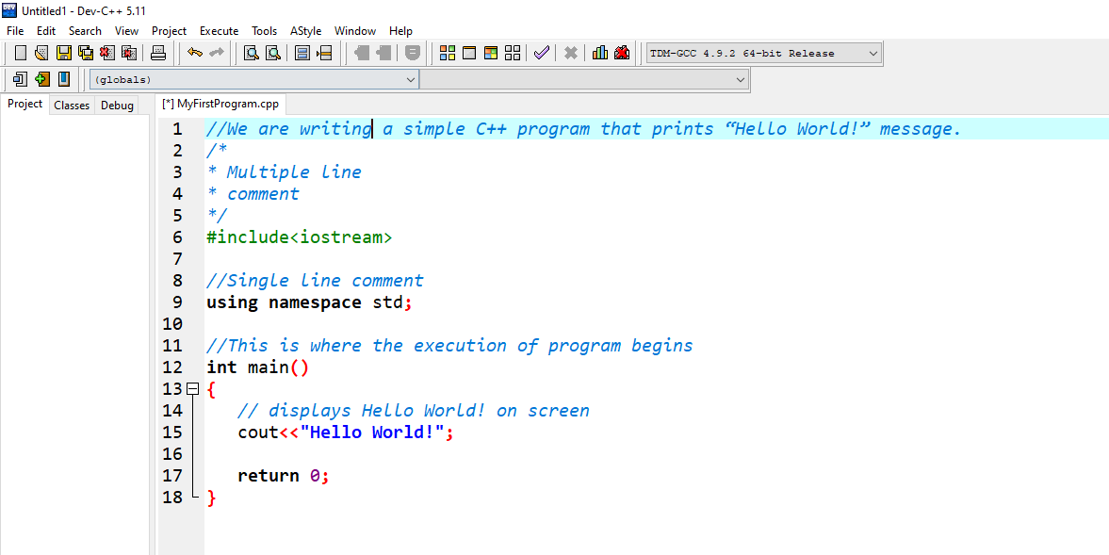

HANDS ON 2: Variable

1. Let us understand variable in c++,! Learn how to declare or “register”a variable.

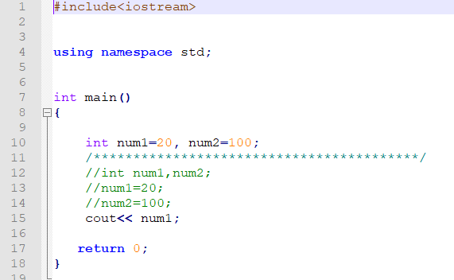

HANDS ON 3: Global Variable

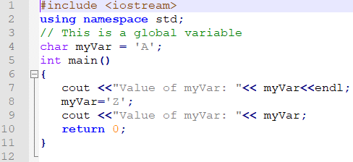

HANDS ON 4: Local Variable

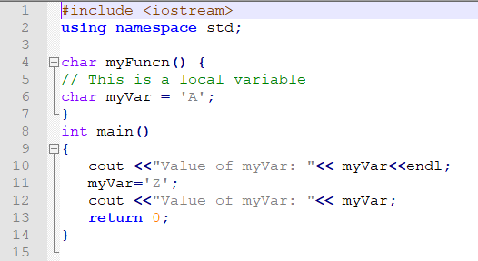

HANDS ON 5: Can local & global variable have the same name? Try to see what happen!

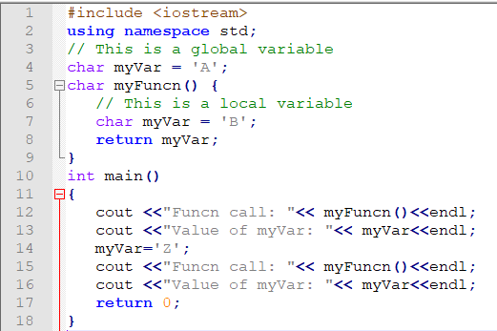

HANDS ON 6: Example of Arithmetic Operators

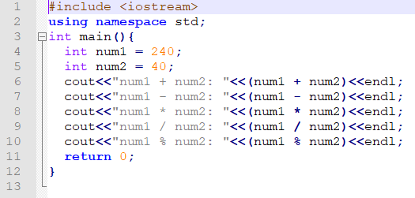

HANDS ON 7: Example of Assignment Operators

